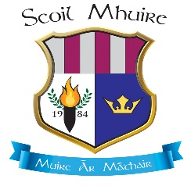
Scoil Mhuire, Woodview Heights, Lucan, Co. Dublin

Junior Infants

PPS NO
Name of Créche/Pre-School/Montessori/ Primary school currently attending:
______________________________________________________________

Childs Full Name on Birth certificate
Country of Birth
Date of Birth
(Birth certificate must be included with this application)
Male or Female
Religion

Home Address

(Utility bill, (gas/electric/waste), must be included with this application)
Brothers/ Sisiters who have attended or are attending this school
Place of child in the Family

Mothers Name
Country of Birth
Home Address
Mobile Phone
Email

Father’s Name
Home Address
Country of Birth
Mobile Phone
Email

For Parents that are living together only one text alerting you of school messages will be sent. Please indicate by ticking the box below the number which will receive these texts.

Mother Father

Emergency Contact
Emergency Contact
Contact Number
Relationship to child
Name of Family Doctor
Family Doctor Telephone

Signed; ___________________________________________ Date: ________________

